
TER 6223 ENTERPRISE RESOURCE PLANNING

PROJECT

TRIMESTER OCTOBER/NOVEMBER 2530

No. | Student ID | Name | Major | Signature
 | 1211110265 | Darren Liew Han Jie | BIA | liew
 | 1211112194 | Teh Wei Yun | BIA | teh
 | 1221308558 | Shiu Li Jie | BIA | Shiu
 | 1211107981 | Ng Xin Hui | BIA | Hui
Declaration by Group Leader
I hereby declare that all group members’ names are correctly included in the above section. I hold a copy of this assignment which I can produce if the original is lost or damaged. I certify that not part of this assignment has been copied from any other student’s work or from any other source except where due acknowledgement is made in the assignment/project/etc.

Group Leader’s Signature: liew
Group Leader’s Name: Darren Liew Han Jie
Group Leader’s ID: 1211110265
Date: 6/2/2025

Role of Members
Member | Roles | Responsibilities
Darren Liew Han Jie | Leader | - Coordinated team tasks and timelines  - Led meetings and integrated contributions  - Managed stakeholder interactions and final reviews
Teh Wei Yun | Analyst | - Studied and documented the food court’s daily operations and business processes  - Identified operational challenges and inefficiencies  - Analyzed how SAP ERP modules can solve the identified problems  - Supported process mapping and benefits evaluation
Shiu Li Jie | Researcher | - Performed on-site observations and data gathering  - Researched SAP modules and ERP best practices  - Contributed to SDG linkages and fact-checking
Ng Xin Hui | Designer | - Designed report layout and visuals  - Created the presentation deck  - Enhanced formatting and diagrams for clarity

Table of Contents
Role of Members 2
Learning Reflection 4
Introduction to the Business Organisation (Madam Yan Bukit Beruang Food Court) 5
Current Business Processes 7
Daily Opening and Preparation Process 7
Inventory and Procurement Process 7
Customer Ordering and Payment Process 8
Cleaning & Maintenance Process 9
Financial Management Process 9
Challenges and Inefficiencies in the Business Processes 10
Fragmented Stall Operations and Lack of Integration 10
Weak Sales Visibility and Manual Cash-Based Reporting 10
Inventory and Procurement Inefficiencies 11
Service Flow Bottlenecks, Queue Congestion, and Peak-Hour Inefficiency 12
Shared-Area Cleanliness, Waste Management, and Facility Maintenance Issues 13
Relevant SAP ERP Modules Based on Observations 14
Brief ERP Implementation Plan 18
Expected Benefits for the Organisation 20
Conclusion 22

Learning Reflection
This Enterprise Resource Planning (ERP) project taught us a lot about how the information technology can link the diverse sections of a business. We able to connect what we studied in our university to the real life by looking at how a real food court operates and come up with an ERP solution. This task taught us more about how the ERP systems help firms make better decisions and function more efficiently.
One of the most essential things that we learned from this project is how crucial it is for the businesses to connect their systems. We used to think that the human resources, finance and inventory were all separate the things. But this project helped us to realize that the ERP systems put all these activities together on one platform. I learnt how to share the information between the departments using the modules like SAP, MM, FI and HCM to reduce the duplication, improve the accuracy and make the processes more transparent.
We had a lot of the troubles when we were doing the tasks. One of the huge challenges was acquitting the right information about how the food court worked. Some of the stall proprietors were busy and didn’t want to give the details. It was also challenging for us to understand how the different SAP modules operated at the first because we didn’t know much about the enterprise systems. We had to conduct the additional research and read scholarly books and the online resources to better understand these issues.
We also learned a lot of the important things from this project. We learned how to interact with each other and discuss for the project plans. Finding the business problems and offering the best ERP solutions helped us to get better at analysing the things. Putting the information in a logical sequence and expressing our opinions in a professional style also helped us to get better at making the reports and giving the presentations.
This research has significantly enhanced our comprehension of Enterprise Resource Planning and its practical applications in enterprises. The experience has given us more confidence in our abilities to look at how firm function and come up with the technology-based solutions. The knowledge and skills that we gained from this project will be very helpful for our future studies and career, especially in the fields related to the business management and information systems.

Introduction to the Business Organisation (Madam Yan Bukit Beruang Food Court)
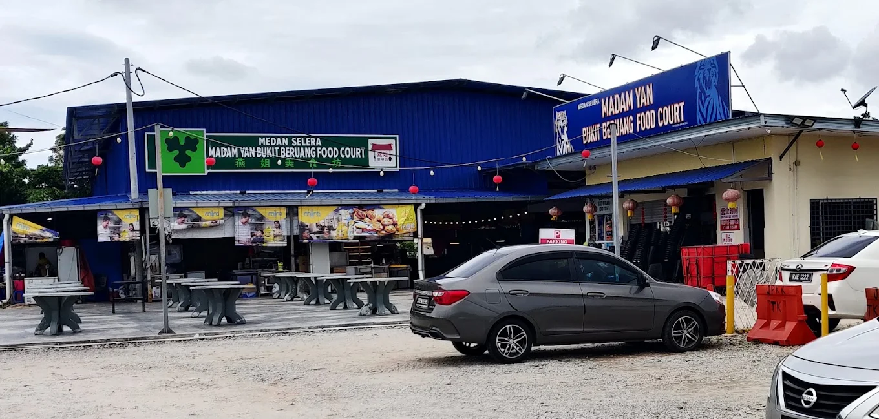
Figure 1: Overview of Madam Yan Bukit Beruang Food Court

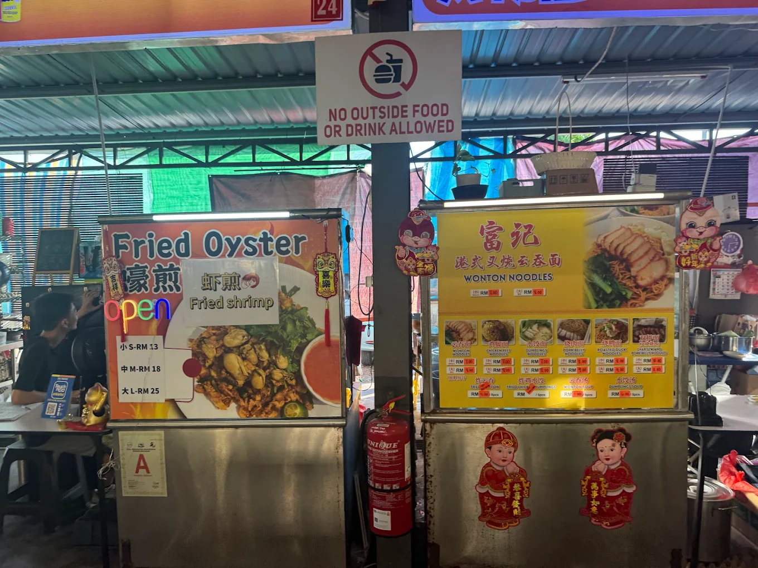
Figure 2: Overview of some stalls

The selected business organization for this case study is Madam Yan Bukit Beruang Food Court (Medan Selera Madam Yan Bukit Beruang). It is a local food court that is in LOT 4427, JALAN DELIMA 12 TAMAN BUKIT MELAKA, BUKIT BERUANG, 75450 Melaka. This food court serves as a popular dining area for both residents and visitors due to its strategic location and accessibility. It is situated near residential areas and schools, which contributes to a steady flow of customers throughout the day. The food court operates daily from 11am to 12am, providing affordable and convenient food options to the community.
The food court has approximately 25 food stalls, offering a wide variety of cuisines such as Chinese, Indian, Western, Fast Food and more. Each stall is operated independently by different vendors, while the overall management is handled by a central administrative team, who are responsible for the facility maintenance, like cleanliness, rental collection and other general operations. The food court has basic facilities like seating areas, dumpster, restrooms, and parking spaces, which support customer comfort and operational efficiency.
One of the unique characteristics of the food court is that it often has promotional activities, like for example, food discounts for university students, to attract customers and remain competitive. Despite its strengths, the food court still relies heavily on manual processes and fragmented systems, which creates many opportunities for improvement through using an ERP system.
Overall, Madam Yan Bukit Beruang Food Court plays an important role in serving the local community with its accessible and affordable dining options. However, as customer expectations continue to evolve and competition increases, the food court must adopt modern management systems like ERP to enhance its operational efficiency and service quality.

Current Business Processes

Daily Opening and Preparation Process
Getting ready to open and making sure everything is ready is the first stage in the daily operating cycle. People who work at stalls come to set up the food, cooking gear, serving containers, and the basic layout of the counter. At the same time, the management side (or hired cleaners and workers) gets the common areas ready by putting up tables and chairs, making sure the trash cans are in the appropriate place, verifying that the water and electricity are working, and cleaning the eating area. The opening process needs to be managed because the venue is shared. If there is an issue with one of the facilities, such a power outage, a water leak, or a clogged drain, it might affect many stalls and the total client experience.
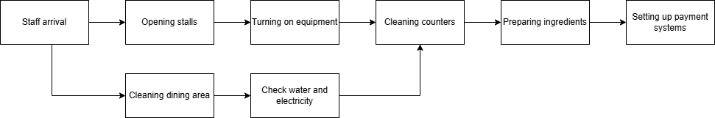
Figure 3: Daily Opening and Preparation Process

Inventory and Procurement Process
The next stage is to buy and restock, which is often done in a decentralized method at food courts. Most of the time, each stall receives its own raw materials (for example, meat, vegetables, rice/noodles, sauces, drinks, and packaging) from vendors they choose. Most of the time, they order these products by texting or phoning. In an "as-is" scenario, purchase records may be kept by hand (with notes, receipts, or basic spreadsheets), and the stall operator's experience, not systematic demand estimates, is often what leads their decisions about what to buy. This strategy works well when the operator is experienced, but it doesn't work as well when demand changes fast, such on weekends, school breaks, rainy days, or special events.
During operations, inventory is always being kept and used, which directly affects how quickly the service is and how good the meal is. Stalls are responsible for storing their own ingredients, which might be both cold and fresh dishes created every day. Workers need to know how much to make ahead of time (to speed up service) and how much to make on demand (to cut down on waste). In real life, this requires balancing every day: if you make too much food, it will go bad faster, and if you make too little, people will have to wait longer and lines will be longer. People need to be highly diligent to check for expired products and rotate stock if there isn't a system in place to keep track of them. Overall, each stall is responsible for managing their own inventory, and inventory levels are usually monitored through visual inspection or manual records. Without a centralized inventory system, issues such as overstocking, understocking and food wastage may occur.
Figure 4: Inventory management Process

Customer Ordering and Payment Process
Customers witness the most critical things: taking orders, making food, and delivering it. Customers look around, choose a stall, place an order, and then wait for their food. Some booths can get ready quickly since they feature ingredients that are already partially cooked. Others need longer to cook. Long queues at popular vendors are the worst thing that can happen when things are hectic. If one stall slows down, it might produce traffic jams in front of that counter, making it tougher for visitors to get around the food court. Customers can assume the whole space is "too crowded" even if there are other vendors operating.
Most of the time, each vendor in a food court keeps track of their own sales and payments instead of a central place. Customers pay at each stall, normally with cash, but sometimes with an e-wallet or QR code, depending on what the stall can do. After that, each stand counts its own money, keeps track of its change, and prepares simple sales reports every day. Then, management collects money on a regular basis based on its revenue model, which might be rent, a cleaning fee, a utilities contribution, or a commission. In a manual arrangement, management might rely on reports from stall owners, leasing agreements, and informal chats instead of a standard system that demonstrates performance every day. Overall, there is no centralized system to monitor customer orders or sales performance across different stalls, which leads to a limited visibility for management.
Figure 5: Customer Ordering and Payment Process

Cleaning & Maintenance Process
Cleaning floors, taking down tables, getting rid of pests, making sure the air is pleasant, and correcting faults with the facility are all examples of shared service processes that happen all day. These tactics don't "sell food" right away, but they do change how people feel about the food court, which is one of the most critical things the guideline states you need to do to be successful. If cleaning isn't done often during the busy periods, the customers may have problems locating clean seats. The food court's reputation might suffer, and the atmosphere could go bad if rubbish isn't picked up quickly away.

Financial Management Process
Financial activities are normally handled manually by individual stall vendors and the central management team. Each stall records daily sales using either handwritten notebooks, simple spreadsheets, or mobile applications. At the end of each working day, sakes data is summarized to calculate revenue and expenses. Rental fees and utility charges are collected monthly by the management office, often through manual invoicing and payment tracking. Financial reports are prepared periodically using basic accounting tools, which can lead to delays and inaccuracies in financial analysis.
Figure 6: Financial Management Process

Challenges and Inefficiencies in the Business Processes

Fragmented Stall Operations and Lack of Integration
One of the difficult things about a food court is that each booth is like a "mini business" with its own regulations and ways of doing things. People conceive of Madam Yan Bukit Beruang Food Court as one place, although the businesses could have different ways of accepting orders, setting prices, and servicing customers. This leads to fragmentation, which implies that a customer could have a fantastic time at one stall and an unpleasant or confusing time at another. This means that the quality of service might change.
Management often doesn't know how things are going because of this fragmentation. For example, stall A might keep track of sales every day, stall B might only count cash at night, and booth C might not maintain any records at all. It might be hard for management to know which procedures are operating effectively, which stalls run out of supply often, or which items make consumers wait the longest if they don't have the same information across all booths. This is hard for management since decisions are based on guesswork and informal feedback instead of real proof of how things are working.
It's also hard to make modifications between delays, which is another concern. In a more integrated company, managers may make sure that procedures are the same, such keeping track of inventories, creating daily sales reports, and establishing plans for staff. But in many food courts, stall owners would rather do things their own way, and management would not want to make strict reporting rules since they could cause difficulties with vendors. Because of this, efforts to improve things are usually late, inconsistent, and met with opposition, which means that the same operational problems reoccur every day.
Not having integration also makes it tougher to grow over time. The current flawed system will get harder to manage if the food court wants to develop (more stalls, more customers, more merchants). As the business gets bigger, concerns like lengthy lines, sluggish service, and inconsistent reporting will get worse. This is why integration is a big "inefficiency driver" in food court operations and an excellent incentive to convert to ERP later.

Weak Sales Visibility and Manual Cash-Based Reporting
Another huge challenge is that it's hard to tell how well sales are going and what buyers desire. Many old-fashioned food courts have distinct sales areas for each stall counter, and each one maintains track of its own sales. Without a unified system, management can't readily see daily totals, peak-hour trends, best-selling items, or changes in how customers act. This is a huge waste of time since company choices like choosing vendors, making cleaning schedules, designing facilities, and planning promotions need precise operational data.
When you write things down by hand and use money, there are also problems with accuracy. When it comes to handling cash, it's crucial to keep your staff in line. It's easy to make mistakes when counting, lose receipts, or forget to write down discounts, especially when staff are busy and in a hurry. If a stall owner doesn't keep track of sales in a neat way, they could not know exactly how much money they make or how much profit they make after paying for materials. It could be challenging to make sure that rent, utilities, or shared fees are fair and being collected effectively if management doesn't report in a formal way.
It's also hard to fix problems fast since you can't see sales in real time. For example, if a new stall becomes popular, a certain menu item sells out quickly, or a stall loses clients because service is slow, management may not notice until they get a lot of complaints or their sales drop. You can't make changes until after they happen if you don't have daily performance dashboards. This makes you less competitive and less likely to maintain clients. The guideline indicates that food courts depend a lot on how effectively they function and how well they treat customers, so not responding quickly is a huge concern.
Also, it is tougher to coordinate efforts when you have to do them by hand. If management wants information, they may have to ask each vendor separately, which adds time and slows things down. An integrated reporting solution is better since it enables management identify patterns across booths right away. Because of this, a lot of food courts are still in "daily survival mode" instead of "continuous improvement mode."

Inventory and Procurement Inefficiencies
Inventory and buying are very important in food courts because most ingredients don't last long and the demand changes every day. The stall owners usually choose what to buy based on what they know from experience, not what they anticipate would sell. Even if having knowledge can assist, it still generates several problems, such ordering too much (which causes food to rot and go to waste) or too little (which causes stock-outs and menu unavailability). Both situations affect earnings and make the customer experience worse since consumers don't like being told "sold out" when they are busy.
Also, procurement is sometimes decentralized, so each booth gets its supplies from different vendors. This makes it tougher to secure discounts on large orders or figure out when things will be delivered. For example, a few booths may buy the same products, including onions, cooking oil, vegetables, and packaging. But if each station buys them on its own, the total cost might be higher. It also makes deliveries harder since providers could come at different times and muck with operations, especially if there are a lot of clients at the time of the delivery.
It's also hard to keep track of trash, expiry dates, and portion sizes. If companies don't keep track of their inventory, they might not always write down how much was thrown out or why (spoilage, over-preparation, wrong projection, or client rejection). You can't cut down on waste in a planned way if you can't see it. Inconsistent serving sizes can also make ingredients more expensive and revenues lower. If portion sizes vary too much, customers may also be unhappy.
Lastly, change of staff makes things worse because inventory control depends on people so much. If a worker with a lot of expertise departs, a new worker might not know how to maintain track of stock, rotate supplies, or cook swiftly. That makes mistakes and inefficiency more probable, which affects how swiftly service is and how consistently delicious the food is throughout the venue.

Service Flow Bottlenecks, Queue Congestion, and Peak-Hour Inefficiency
A lot of people desire to eat at food courts at the lunch and dinner time. The fact that the Madam Yan Bukit Beruang Food Court has several stalls means that different stores have different numbers of employees and preparation times, which makes it almost difficult to avoid crowds at busy periods. But when stalls don't have enough products ready, when ordering lines aren't clear, or when money collecting takes too long, congestion becomes a significant problem. Sometimes, customers have to wait longer, and the venue's total "throughput" (the number of customers served per hour) goes down.
A chain reaction happens when there is too much traffic in the queue. People that stand in line in front of popular merchants block the sidewalks and make things congested. It makes dining less comfortable and makes it tougher for customers to look at other vendors. since of this, shoppers may pick based on how easy it is to get to a booth instead of how good the product is. This might mean that certain booths miss out on sales since customers can't easily get to them when it's busy.
When things are hectic, orders could also be less accurate and regular. It's tougher to converse to each other when people are in a rush, and mistakes happen more often (wrong order, missing items, improper portion size). Mistakes mean that work has to be repeated, which slows things down even more. This makes a "cycle of inefficiency": hurrying causes mistakes, which causes more waiting, which causes traffic jams, which causes more stress and mistakes.
These inefficiencies during busy times have a direct impact on how satisfied consumers are. Even if the food was good, customers usually remember how long they had to wait and how difficult it was to order. The guideline indicates that food courts depend a lot on how consumers feel and how smoothly they function. Long wait times and congested spaces are two key difficulties that make people less likely to come back.

Shared-Area Cleanliness, Waste Management, and Facility Maintenance Issues
A food court's customer experience is substantially different from that of a single restaurant since it depends on shared features including tables, chairs, trash cans, ventilation, and cleanliness. It's not always clear who oversees common spaces when things are "as-is," or they aren't well-managed. Customers have a hard time finding clean places to sit when tables aren't removed and garbage isn't taken away quickly. This slows down turnover. When turnover is low, fewer customers may eat at the same time, which means that all booths may sell less right away.
Waste management is another area where inefficiency shows up right away. Food courts make a lot of rubbish from food, packaging, and drink containers. When there are a lot of people around, the dumpsters might overflow and make the area smell awful or seem dirty if they aren't emptied regularly. This makes customers think differently about your firm, which might make them leave fast or not come back. It may also make things dirtier by drawing in bugs, which makes issues worse in the long run.
There might also be difficulties with the building's maintenance, such the water supply, lighting, ventilation fans, and drainage. One failure might affect more than one stall at a time since things are shared. For example, if the water goes out, you can't wash, clean, or cook meals. If maintenance is only done when something goes wrong, small problems might become huge ones that hurt the business.
A lot of food courts clean and maintain by hand, which makes it hard to prove that tasks were done on time. If there isn't a systematic way to do things, management can only find out about difficulties when customers complain. This makes it challenging to create a consistently comfortable dining environment, even if management wishes to maintain standards high, because it takes so long to respond.

Relevant SAP ERP Modules Based on Observations
According to the review of existing business processes of Madam Yan Bukit Beruang Food Court and the inefficiencies pointed out in section above, we would recommend the implementation of five major SAP ERP modules. The following modules have been chosen to deal with the difficulties of disjointed operations, mismanagement of inventory, financial transparency, and facilities upkeep. The analysis below explains the justification of each of the modules and how they can be directly applied in the operations of the food court.
SAP Sales and Distribution (SD)
- Target Issue: Disjointed Stall Processes, Service Bottlenecks and Queue Congestion.
- Observation: The food court is now experiencing the problem of fragmented operations in the stalls where each stall is a mini business with inconsistent ways of making orders. This results in bottlenecks in service flows and congestion of queues, especially during rush hour because customers literally queue at each counter to place orders and pay.
- Module Rationale: SAP SD module deals with the whole process of Order-to-Cash. SD will be important in standardization of customer interface in the case of Madam Yan. Using a centralized Point of Sales (POS) or a QR-code ordering system based on the SAP SD, the food court will be able to standardize the ordering procedure of all vendors.
- Operational Solution:
- Centralization of the Order Processing: Customer orders will be digitalized and sent straight to the applicable stall Kitchen Display System (KDS). This will do away with manual order taking and shorten the cycle of inefficiency brought about by rushing and manual errors.
- Dynamic Pricing/Promotions: SD module will enable the management to offer promotions or peak capitalizations of the venue to handle the demand situations where the customers may avoid busy stalls just because of the availability of access to queues.

SAP Materials Management (MM)
- Target Challenge: Waste in inventory, Stock-outs and Decentralized Procurement.
- Observation: The stall owners are now using experience and guess work to decide what to restock, either resulting in spoilage through over-ordering, or stock-outs which result in missed sales. Moreover, the procurement process is decentralized, and stalls purchase ingredients individually, which does not allow it to gain possible bulk discounts.
- Module Rationale: SAP MM is preoccupied with the Procure-to-Pay and the Inventory. It shifts the business into responsive buying to material planning which is based on data.
- Operational Solution:
- Reorder Point Planning: The system may have the minimum stock levels of the most important ingredients (e.g., rice, oil, poultry). A stock below this level will automatically cause a purchase requisition in SAP MM so that the sold-out situations that destroy customer satisfaction can be avoided.
- Vendor Aggregation: With SAP MM, the management will have the option of consolidating orders to common suppliers (packaging, cleaning fluids, staple ingredients) across the multiple stalls. This remedies the ineffectiveness of the so-called decentralized procurement and enhances bargaining power with the suppliers to reduce costs.
- Waste Tracking: The module provides the ability to specifically record waste/spoilage causes and provide the management with the visibility of the issue of waste management which are not currently quantifiable.

SAP Financial Accounting (FI)
- Target Challenge: Lack of Sales visibility, manual cash reporting and revenue leakage.
- Observation: The food court has weak sales visibility as it manually handles its cash. Sales are usually done manually, and there is a possibility of calculation error, misplaced receipts, or theft. The management does not have a single system that can assess the daily performance totals.
- Module Rationale: SAP FI will offer the single source of truth of the financial well-being of the organization. It is used to make sure that every transaction that is recorded in the SD module is reflected instantly in the General Ledger.
- Operational Solution:
- Real-Time Revenue Recognition: Sales are counted in real-time as opposed to manually doing it at the end of each day. This will negate the possibility of revenue leakage and will guarantee the correct calculation of rent, utilities and commission fees using actual data.
- Profitability Analysis: Having correct data about sales (SD) and material costs (MM), SAP FI will enable stall owners to realize their actual profit margins, which will no longer keep them in the everyday survival mode, but instead in financial planning.

SAP Plant Maintenance (PM)
- Target Challenge: Cleanliness of Shared Areas, Waste Management and Reactive Repairs.
- Observation: Shared facilities such as ventilation, drainage and furniture are very critical of the customer experience. Today, the situation with maintenance has been reactive, in the sense that the problem is not solved until it is broken, e.g. water leakage or clogged drains that affect several stalls. Moreover, poor scheduling means that waste bins are commonly overflowing in the times of rush.
- Module Rationale: SAP PM will be crucial in handling the physical assets of food court. It changes the maintenance approach to preventive maintenance.
- Operational Solution:
- Preventive Maintenance Schedules: The system will be able to put together the regular checks of the key utilities (ventilation fans, grease tabs, water lines) to avoid the "huge problems" that interrupt business.
- Hygiene Management: Cleaning jobs can be considered as maintenance jobs. It can issue warnings to cleaning staff to empty the bins or sanitize the tables within peak-hour shifts so that the shared seating area will remain attractive to customers.

SAP Human Capital Management (HCM)
- Target Challenge: Employee Churning, Schedule Inefficiency and Skill Variation.
- Observation: The high turnover rate and use of manual scheduling pose operational risks. In case an experienced worker is gone the new worker may not understand how to keep track of the stock and this will result in errors. Also, the peak hours need specific staffing that is now hard to organize.
- Module Rationale: The HCM module deals with the Hire to Retire. It assists in standardization of the management of the workforce in a high turnover setting such as a food court.
- Operational Solution:
- Shift Planning: HCM enables management to set schedules on how the staff should work depending on the peak times based on the sales information so that sufficient cleaners and servers are available during the lunch and dinner hours.
- Training Management: The system will be able to monitor the employees who have undergone the required food safety and system training, and the errors and ineffectiveness would be minimized because of the untrained staff.

Summary of Module Integration
The true value of this ERP proposal lies in the integration of these modules. SAP SD (Sales) will drive the demand data that informs SAP MM (Inventory) on what to buy. Simultaneously, SAP FI (Finance) will track the flow of money from those sales and purchases, while SAP PM (Maintenance) and HCM (HR) ensure the physical facility and workforce are available to support these operations. This holistic approach addresses the "lack of integration" that currently hinders Madam Yan Bukit Beruang Food Court.

Brief ERP Implementation Plan
This section is used to talk about the ERP implementation plan for Madam Yan Bukit Beruang Food Court, based on the selected SAP ERP modules, SD, MM, FI, PM, and HCM. A phased and rapid deployment approach is recommended to ensure an effective system adoption without disrupting employees’ daily operations.
Phase 1: Project Preparation and Planning
During the initial phase, an ERP project team will be established, which consist of a project manager, who is the leader responsible of managing the project operations. Next, it will have management representatives, as they make the final decisions, for example, the budget approval or policy changes and they set the business directions. Next, are stall operators, they are needed because they know the actual real operations like how orders are taken, how stock is used, they can help design workflows. They are also responsible in testing the system in order to not fail. The main objective of this phase is to define the project scope, objectives, budget, and key performance indicators.
Detailed business process mapping will be conducted to align current business processes with the SAP modules. Relevant data like product menus, supplier records, employee information, and financial documents, will be collected and prepared for system migration.
Phase 2: System Configuration and Data Migration
In this phase, the selected SAP ERP modules (MM, FI, HCM, SD, PM) will be configured based on the operation requirements. Standard system templates will be used to reduce the customization time. Existing data from manual records and spreadsheets will be cleaned, validated, and then migrated into the ERP system.
The SAP SD module will be configured to support the centralized POS and QR-code ordering systems. The MM module will be set up for inventory tracking and procurement. The FI module will be configured for real-time revenue recording and financial reporting. The PM module will be prepared for maintenance scheduling and hygiene management, while the HCM module will be configured for staff scheduling and training records.
Phase 3: System Testing and User Training
Testing for the finished system will be conducted to make sure that all modules can function correctly and meet operational requirements. This includes unit testing, integration testing, and user acceptance testing, involving selected stall operators and management staff.
Pilot testing will be carried out on a few stalls to evaluate the system performance in real scenarios. Any technical issues, usability problems, or workflow problems that is identified during testing will be recorded and fixed upon.
At the same time, training programs about the system will be conducted for the management staff and stall operators and employees. They will receive hands-on training about system monitoring, order processing, inventory updates and more.
Phase 4: Live system
The ERP system will be deployed during low-traffic period, avoiding peak hours to prevent disrupting business operations. Technical support teams will be on standby to resolve any system issues, help users, and optimize the system performance. Performance indicators like order processing time, inventory accuracy, financial reporting speed, and others will be monitored and recorded for future use.
If the system is stable, the existing manual system will be gradually phased out, so that full reliance of the ERP system will be established.
Phase 5: Future support
After the deployment, future support and evaluation will be given. System audits will be conducted to maintain the usability of the system. Feedbacks from stall vendors and management employees will be collected to know which area needs to be improved. System updates, training sessions, and refinements will be given to make sure the sustainability and adaptability of the business in the future.
Implementation Timeline for Madam Yan Bukit Beruang Food Court
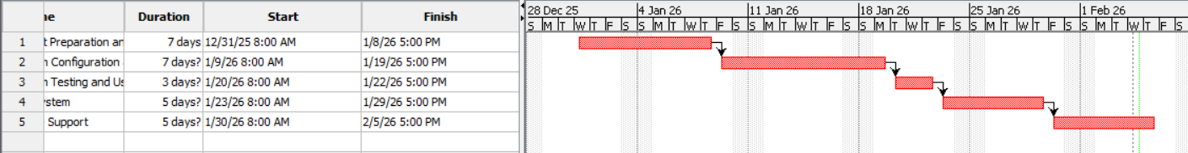
Figure 7: Implementation Gantt chart
Figure 8: Implementation Network Diagram

Expected Benefits for the Organisation
The implementation of SAP ERP modules can bring a lot of benefits, which can be operational, financial, environmental, and social benefits to Madam Yan Bukit Beruang Food Court. These improvements can not only enhance business performance of the food court but also support sustainable and social responsible business practices.
Operational Benefits
The implementation of SAP ERP modules for example the SD module will make customer ordering and payment processes simpler through the centralized POS and digital ordering system. This can reduce queue congestion, minimize order errors, and improve service speed, especially during peak hours.
SAP MM modules can also enhance the inventory visibility and control by enabling accurate stock monitoring and automating stock up. This will reduce errors like stock shortages, and overstocking.
SAP PM will also improve facility maintenance and hygiene management through the preventive maintenance scheduling and systematic cleaning tasks. This can make sure the dining environment is safer and more comfortable for customers.
SAP HCM also support efficient workforce management by optimizing staff scheduling and monitoring training records, making sure that employees are skilled enough to resume operations during peak hours.
Financial Benefits
Implementing the SAP SD and FI into the business operations can enable users to track real-time revenue and financial reporting. This can significantly reduce human errors, revenue leakage, and enhance financial transparency.
A centralized procurement through the SAP MM will allow the food court to buy supplies in bulk and negotiate with suppliers, which can lead to lower procurement costs.
An accurate cost tracking and profitability analysis by the modules will also let management and stall vendors make informed financial decisions, improve budgeting practices, and enhance long-term financial sustainability.

Environmental and Social Benefits
The use of the SAP MM for inventory planning and waste tracking will significantly reduce food spoilage and unnecessary disposal. This can contribute in the environmental protection and responsible resource utilization. Digital transaction records and electronic documentation can reduce the paper usage, which can be environmental friendly.
The improved hygiene management and facility maintenance through the SAP PM will promote public health and food safety standards.
The Contributions to the UN Sustainable Development Goals (SDGs)
SDG | Description | ERP Contribution
SDG 2 | Zero Hunger | Helps in reducing food waste through inventory control and tracking.
SDG 3 | Good Health and Well-Being | Enhances hygiene of the food court and food safety of it.
SDG 8 | Decent Work and Economic Growth | The proposed system improves the payroll accuracy and staff welfare for employees.
SDG 9 | Industry, Innovation, and Infrastructure | The proposed ERP system promotes digital transformation of the existing manual system.
SDG 12 | Responsible Consumption and Production | The system encourages waste reduction and efficient resource use through inventory control and tracking.

In summary, the proposed SAP ERP system will bring tons of benefits to Madam Yan Bukit Beruang Food Court in terms of operational efficiency and financial management.

Conclusion
This project analysed the operational processes of Madam Yan Bukit Beruang Food Court and identified key challenges related to order management, inventory control, financial reporting, facility maintenance, and human resource management. To address these issues, the implementation of SAP ERP modules, including SD, MM, FI, PM, and HCM, was proposed. The proposed system is expected to improve operational efficiency, financial transparency, reduce food waste, and strengthen workforce management. Other than that, the ERP also supports the sustainable and social responsible practices together with the UN Sustainable Development Goals SDG. Overall, the ERP solution will enable the food court to operate more systematically, competitively, and sustainably. We hope the food court will be much better prepared to meet future business challenges.

